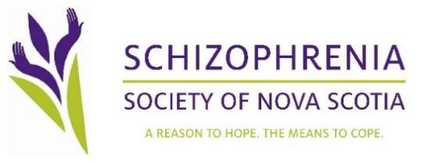
Community Living Program Overview
Introduction:
At the Schizophrenia Society we believe recovery happens in community. Our mission at the Schizophrenia Society is to provide you with the tools and supports to live in community successfully. So how do we do this? We do this by providing education, managing landlord tenant relations, weekly meetings, problem solving, dispute resolution and act as a liaison/advocate for the individuals in our program. We at the Schizophrenia Society will do all that is possible to support those in our program to achieve success. Nevertheless, as an individual entering our program there are several conditions you must follow in order to be admitted and remain in the program.
Terms of the Program

- No drugs or alcohol
- No Smoking in the apartment
- Must maintain reasonable level of cleanliness and hygiene
- Must attend weekly meetings
- Must take prescribed medications
- Must follow conditions of lease
- Come to us with any issues/concerns regarding tenancy
- Must respect privacy and rights of roommate
- No overnight visitors
- Review all education material provided
- We have ultimate authority over the apartments and selecting roommates
- Must participate in either One to One Peer Support or FR2D for one year
- Must have a confirmed medical diagnosis
- Must be willing to sign capital health medical information release form stating SSNS can discuss your medical information
- Must have a clinical community support
- Must have secured funding through Department of Community Services
- No pets while enrolled in our program

Consequence for noncompliance

Depending on the severity of noncompliance the Schizophrenia Society will respond according to SSNS policy. Noncompliance will be defined in two ways. Major noncompliance and minor noncompliance. Major noncompliance includes but is not limited to, not taking medication, consuming drugs or alcohol and breaking terms of lease. In the case of a major noncompliance a written warning will be issued immediately and if the individual continues to not comply with the programs policy they will be demitted from the program and support from the Schizophrenia Society will be withdrawn. A minor noncompliance includes but is not limited to maintaining a reasonable level of hygiene and cleanliness of the apartment and themselves, not attending weekly meetings, and not respecting the privacy and rights of roommates. In the case of minor noncompliance, a verbal warning will be issued and the reason for noncompliance will be addressed. If the noncompliance behaviour continues a written warning will be issued. If noncompliance continues after the written warning the individual will be demitted from the program and the Schizophrenia Society will withdraw support.

Re-entry after dismal from program
Once an individual is removed from the program, they will need to meet the following conditions before resubmitting their application. Reapplication is not a guarantee you will be placed back into the program. If you have been demitted from the program for a second time you will no longer be a candidate for the program.

Conditions required for re-entry into the program
- If demitted from the program the applicant must wait one year from the date they were dismissed from the program before they may reapply.
- The applicant will need a signed doctor’s note stating their wellness.
- The applicant will then need to follow the standard procedure for applying into the program.
Summary
We at the Schizophrenia Society will do all that is possible to support you in your recovery process. Nevertheless, you will need to work with us in order to support you successfully. By signing this document, you are agreeing to the policies set forth by the Schizophrenia Society.

Name:_______________________________ Date:______________________________

Witness:_____________________________ Date:______________________________

